BROKEN NECKLACE FOUND IN STOCKS HILL

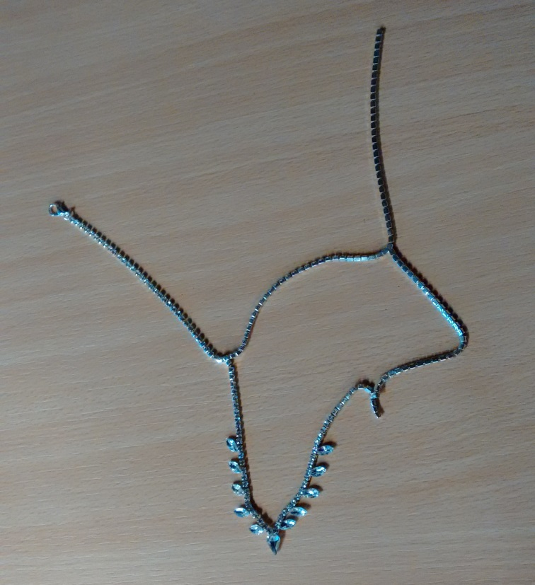

PLEASE CONTACT
SARAH AYLING, PARISH CLERK
PARISH OFFICE, 2 STOCKS HILL LANE
KETTON, STAMFORD, LINCS
PE9 3TW
TEL 01780 722159 OR EMAIL kettonpc@btinternet.com

