Rutland County Council
Plan 7 - Ketton
Red = Double Yellow Lines (No Waiting At Any Time), Green = unrestricted advisory parking bay (2m wide), Black zigzag = existing Pedestrian Crossing, Red zigzag = extension to Pedestrian Crossing, Yellow zigzag = existing School Keep Clear markings
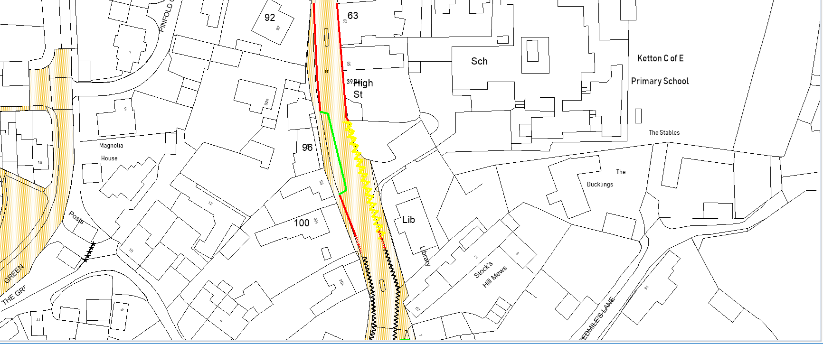
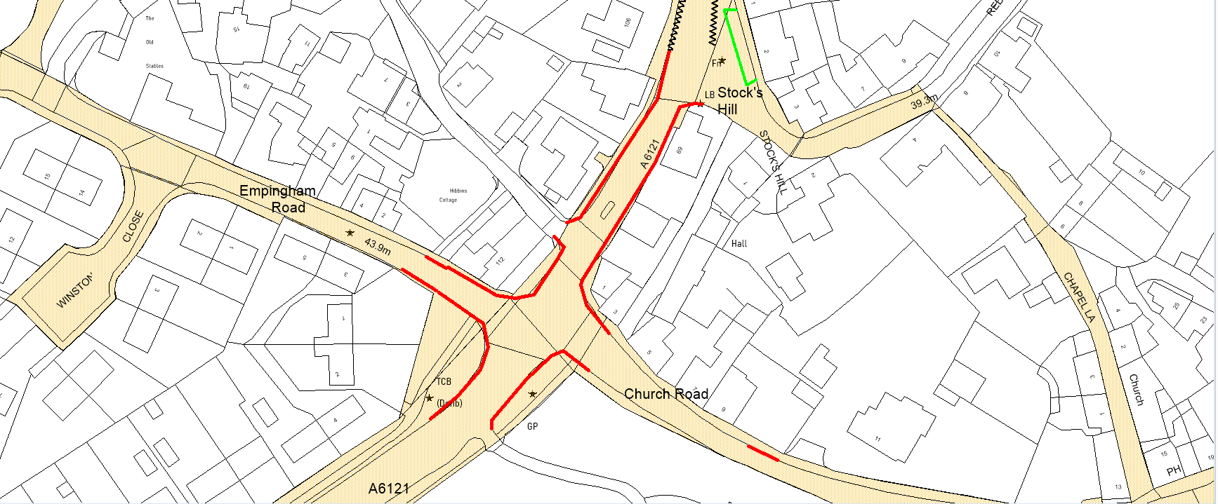

Maps have vertical northings and are to varying scales. © Crown copyright and database rights [2020] Ordnance Survey [100018056]

