Garden Bonfires advice from
https://www.gov.uk/garden-bonfires-rules
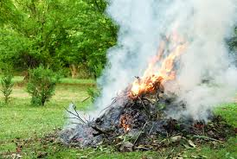
Garden bonfires: the rules
There are no laws against having a bonfire, but there are laws for the nuisance they can cause.
Burning domestic waste
You cannot get rid of household waste if it will cause pollution or harm people’s health particularly if they have a health condition affected by smoke.
This includes burning it.
You can get rid of household or garden waste by composting or recycling it.
Please be considerate - everyone is spending much more time at home and in their gardens.
https://www.rutland.gov.uk/#

