On Monday evening 8th June a group of youths vandalised the play house in The Hall Close junior play area. They also deliberately smashed a bottle and spread broken glass underneath the swings.
If you witness any anti-social behaviour in Hall Close please ring 101 and report to the police or Ketton Parish Council.
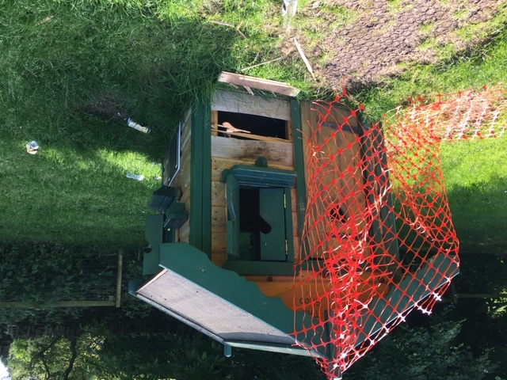

Ketton Parish Council 01780 722159 kettonpc@btinternet.com

