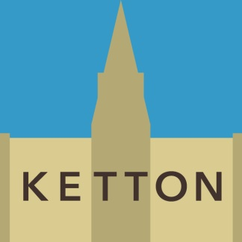
Coronavirus
(COVID-19)

The children’s play areas in Hall Close remain closed until further notice – subject to a change in government advice

KETTON PARISH COUNCIL 20 MAY, 2020

