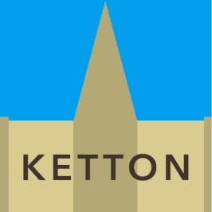

COME AND MEET
KAREN PAYNE & GORDON BROWN
RUTLAND COUNTY COUNCILLORS REPRESENTING KETTON WARD

ON THE FIRST SATURDAY OF EVERY MONTH IN
BARROWDEN VILLAGE SHOP
BETWEEN 9 & 10AM
&
KETTON COMMUNITY HUB/LIBRARY
BETWEEN 10.15 & 11.15AM

